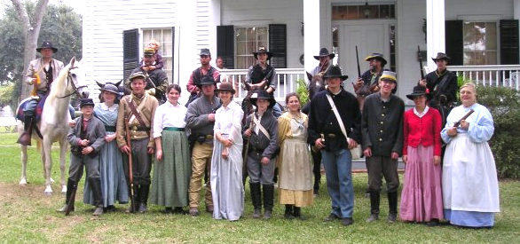

Fire, Sword ,& Halter

Volume 4 Series X
News Letter of the Third Regiment of Texas Cavalry Reenactors
www.3rdtexascavalry.org
October 2008

Commanders Corner
It is a great pleasure to be your leader and to camp and share this hobby with you. It is through this hobby that I have met many of my closest friends. Often events are like family reunions where we get together and meet and talk between getting ready to perform the next battle for the crowd. I would here like to propose a slower weekend of just enjoying camping and hanging out, yes you can drill, yes you can shoot at each other, you can cover all of the 200 acres you want but you don’t have to. The 3rd Texas Cavalry and Camp Anderson Military Museum (CAMM) are hosting a Christmas party the weekend of December 13 and 14. This is to be a Reenactors weekend, your weekend so tell me what you want, please hurry so we can figure out how to do it and how much it will cost, fees will of course depend on how much it costs to put it on. CAMM is a neat place, for more information on it read the article Camp Anderson Military Museum in this publication. It will be great times so please RSVP soon.
Thank you to our carpenters, The Clinch family and Cpl. McDonald have proven their carpenter skills. The 3rd Texas now has the use of a saddle rack, rifle rack and a cook station as well as a new HQ box. Thank you to you all for your work to make this group a success.

Event Schedule

Nov. 21-23 Liendo Plantation, Hempstead
December 12-14 Christmas Party at Camp Anderson
February 6-8 2009 Madisonville
April 3-5, 2009 Pleasant Hill
May 1-3, 2009 Port Jefferson
For more information on events check out the website, www.3rdtexascavalry.org

EQUINE INFECTIOUS ANEMIA AND THE COGGINS TEST

By Robert N. Oglesby, DVM
INTRODUCTION
Equine Infectious Anemia is a viral disease for which there is no vaccine and no cure. Though most horses succumb rapidly to EIA a percentage of infected horses appear to recover. However they still harbor the virus and during times of stress may become ill again. It is because of these healthy appearing carriers that we test horses. It insures that we do not put their pasture mates at risk.
TRANSMISSION
Recently we have learned more about the transmission of this disease. The disease is spread by horseflies. The large horsefly is the main vector. If they bite an infected horse and then bite a healthy horse, the disease gets transmitted. The virus does not live for very long on the horsefly, maybe as little as fifteen or thirty minutes. So for one horse to infect another they must be close to each other. This disease occurs anywhere horseflies live.
CLINICAL SIGNS
Three different sets of symptoms occur: acute, chronic and the asymptomatic carrier. With acute infection the horse has fever, depression, and no appetite. The acute horse may be difficult to diagnose because the symptoms are very general and he will not be positive on the EIA test for a month and a half. Approximately one third of infected horses will die of the acute form within a month.
The chronically infected horse will having recurring acute bouts along with weight loss, ventral edema (swollen belly and legs) and anemia. These horses will be positive on a EIA test. These horses may linger for a year or more before they die.
Most asymptomatic EIA infected horses will not show any recognizable signs but will test positive on a Coggins test.
COGGINS TEST
To insure that an animal is not harboring the virus a simple test is performed, the Coggins test. The Coggins test checks for Equine Infectious Anemia (EIA) antibodies in the horse's blood. Blood samples must be sent to a state approved laboratory. This test is often needed to take your horse to a show and whenever you transport your horse across state lines. It is to prove to others your horse is safe to be around their horses. Some states now require a negative Coggins test on a horse before he can be sold. Before you travel check to see how recent a test is required because it differs from place to place.
Once you have a negative Coggins further testing is not required for your own peace of mind. Your horse will not become EIA positive unless he develops a serious, febrile illness after contact with a horse of unknown EIA status. You may be required to have a test done yearly to show or transport your horse, so other people will know your horse is safe.
PREVENTION
The current testing program has gone a long way toward reducing this disease. Few people remember, prior to the testing in the 1970's that this disease killed many thousands of horses annually. It was originally thought that the testing program would eradicate EIA but every year there are just enough asymptomatic carriers to perpetuate the problem.
There is no vaccine for EIA. It is important that you be careful that your horse's pasture mates are as healthy appearing as your own horse. Board your horse only where a negative Coggins test is required of all horses before they come on the premises. This is your best protection.
A CURRENT coggins test to with in one year in Texas and only six months out of state is required on all horses or you will not be allowed access to the event site. It is a good idea to make copies and keep originals in a notebook in your towing vehicle. Place a copy in your saddle bags and if some one else is hauling your horse give them your notebook and carry a copy yourself☺ Also some events require a health certificate good for thirty days.
School Of the Soldier

Graining
For mounted troopers and officers the most important part of the weekend is the feeding and watering of the horse. Our mounts are totally dependant on us for their nutritional needs, more so than at home. At an event they are attached to a picket line and not able to move about and fend at all for themselves. The picket is under to charge of the Stable Master, a junior officer or senior NCO assign to the task for the weekend. All horses should be checked in to a picket with the Stable Master or person in charge in their stead. Fresh clean hay must be maintained at all times for all horses on the line. This keeps the animals quite and gives them something to do munch. This is mush like the chips and dip at a Mexican food place, even after eating we still will find ourselves dipping chips☺ Horses must be watered each evening and morning in addition to watering throughout the day. Horses will be grained twice a day at times designated by the Stable Master. It is best to use a nose bag to grain the hoses and this is highly encouraged. The use of the nosebag makes graining easier and prevents confusion and fights on the line. Every effort should be made to acquire a correct nosebag as soon as you can. These can be the suttler bought issue style or a CS hand made. As all way if you have a question ask☺

“Principles and rules are intended to provide a thinking man with a frame of reference.”
Karl Von Clausewitz

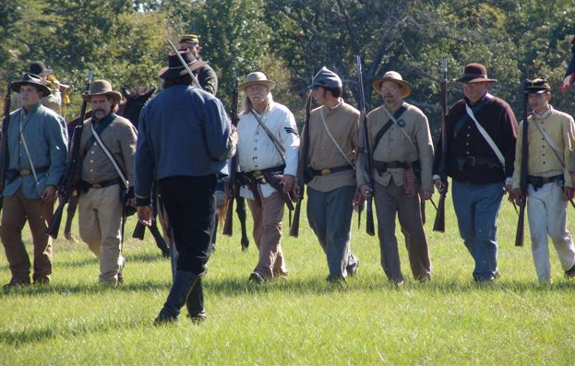
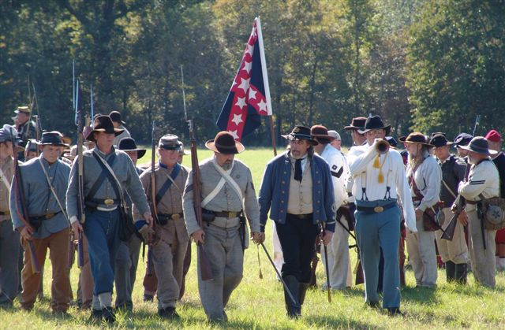

Reports
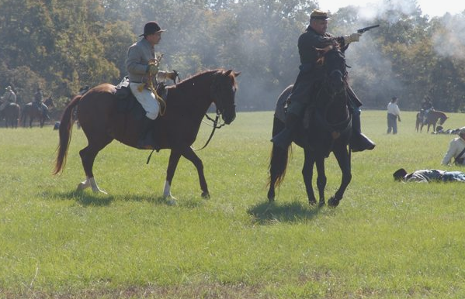
Raid on Camp Ford

In response to orders received from HQ the 3rd Texas made its way to Jones’ Meadow some ten miles west of Camp Ford. Although rumors of Federal activity from the local population seemed unlikely we did go into camp and set up pickets in the area. As the van of the 3rd arrived we discovered a small disorganized force of home guard in the area. As senior officer in the region I took charge of the situation on organized a battery, two platoons of infantry, one of dismounted cavalry and two more of mounted troopers. On Friday the Good Lord Blessed us with a beautiful day and by 10 o’clock we were hosting some 500 young scholars. Just past the noon hour we put on a skirmish for their entertainment and by two the camps were again peaceful. As evening fell the rest of the troop arrived and we were at our full expected strength of 7 mounted.
Saturday morning came and the QM provided an excellent breakfast and the bugle and I with our escort attended officers’ call. I again marshaled the troops providence provided me and made arrangements to throw out a strong picket made up of our dismounted troopers supported by the infantry. The Artillery was placed to the center of the field to cover the road going to Tyler and the cavalry was sent out to forage and look for signs of federal activity. The Capitan of the Infantry visit my HQ about an hour before the noon to request permission to drill his command in the open field due to the wonderful weather, a request I quickly granted as I had considered making such an order.
Around the 1 o’clock hour I mounted to go out and watch the drill and allow the infantry to march in review. They were handled quite well and for home guards proved to be ready for any fray. It is good that they were as about two in the afternoon a ride came up the Tyler road from the west heralding the advent of a Yankee invasion. Much to our surprise it did not take long before we could hear the gunfire from our pickets. Ordering the bugler to follow and the infantry to stand fast I moved forward to see the extent of the emergency. As I crested the ridge I could see our pickets firing into the woods and smoke rising from near the road proved the report of the rider. As Federal pickets emerged from the woods forcing back our own it became obvious that there was a force stronger than expected moving toward us. I quickly ordered the bugler to recall the cavalry and have them form to our left. I told the pickets to fall back but to make the federals earn it.
Hoping to mask my guns and my infantry I planed to pull the federal forces into the open and strike. Abe did not disappoint, for what ever reasons the federal came out and pushed us hard. The battle moved back and forth across the field that became littered with the cost of our struggles. As my commanders reported in that their ammunition was running short and I feared I might have to pull off this field which found us in a favorable position the Federal commander asked to speak with me. As the contest had left many a wounded man on the field the Abe asked for a cessation of the conflict so as to remove those unable to fight from the field, it was agreed that we would do so and not resume the conflict for 24 hours. This was very favorable for us as it allowed us to maintain our tenable position and to bring up ammunition from the stores in Tyler.
Doctors also made their way out to the site to start their ghastly work. Having made arrangements for our own wounded and assigning details to take care of those who had paid the ultimate price I took leave to return to camp. My thanks to the QM corps for the fine meals the entirety of our time spent in the wilds west of Tyler.
Morning again broke and it came time to meet with my officers to prepare for the days work of pushing the federal interlopers from our borders. As the hour approached that would end our truce I ordered our guns to our extreme left hoping they would open their right to us. Holding our mounted branch in reserve for what ever might come the skirmish line pushed forward at the appointed time and found the feds. Falling back they pulled the yanks out into the open. Just as we had hoped their right was open to enfilade fire from our battery, as they turned to meet that threat I threw forward the infantry forcing the Union commander to refuse his right and fall back. In response he also ordered his mounted troops to attack our right and try and turn our guns. We were able to meet this with our mounted branch and continue to push him back on his guns. As their position became less tenable his desperation doubled as mounted home guards arrived on the field from Tyler falling on his right flank almost in his rear causing him to almost form a square as we were able to tighten our noose.

In desperation the federal commander was unable to defend his position I then sent word to him that I would give him terms. He responded that he would hear them and we ceased our hostilities. My terms were quite simple and to the point, as they had desired to go to Camp Ford we would grant them safe passage and escort to said place were they could live out the duration of the war.

Respectfully Submitted by:
Major Dyson Nickle, Commanding CS forces in and near Tyler Texas.

Quiz Yourself
- In Vol. 2 S. V ‘s School of the Soldier what was the lesson 87 called? Balance Step
- In Vol. 4 S. V Bob Sullivan said you should never do what? Move
- What is the URL for our new website? www.3rdtexascavalry.org
- List two battles the 3rd Texas Cavalry fought in during 1863. There are several to choose from.
- What is the deadline to register to vote in the November election? Oct. 6

“If you want to have a good time, Jine the Cavalry!!!

Quiz Yourself
- What major National event that we wanted to attend has been cancelled?
- How many horses are there in a set?
- How many rounds can a LaMat revolver fire?
- How many times did the 3rd Texas Cavalry cross the Mississippi River during the war?
- Where did Gen Hogg die?

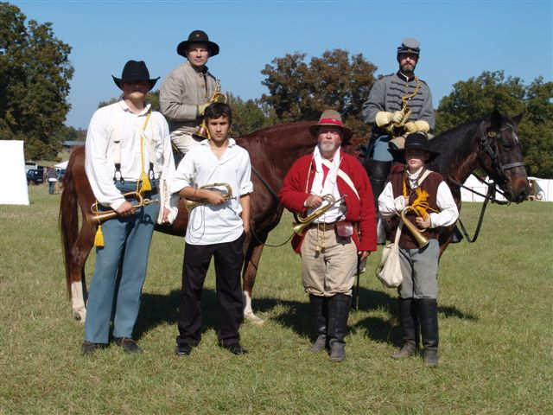
Command and Communications
These gentlemen have done so much to improve the command structure of our events. No longer must a commander shut at the top of his lungs in hopes that an order is heard. In the same way that they did it so now may we. Thank you to each of you for your hard work and dedication to the hobby, you all sounded great and you can all be proud of the service you provided. Sirs and Ladies, the Trans-Mississippi Bugle Corps

